Processing of WEB camera video information

Student: Iordache Ana Maria

Group: 30433

1. **Introduction**

Due to the continuous development of technology, no matter if we refer to either hardware or software domains, it is only natural that the human kind is vigurously looking for the most efficient solutions to solve their problems and ease their day to day life.

As for the aim of this project, a subject that has attracted great interest is that of the way we understand and envision the world around us while creating a mean of parsing and interpreting such information with the help of computer software, namely Computer Vision. By digitalizing the process of analyzing video and image information, we are able to get a high level understanding of it and automate the tasks the the human visual system can do.

Computer Vision is a complex set of image-handling specific tasks, such as: object recognition, motion analysis, scene reconstruction and image restoration. The most common applications of Computer Vision and Image Processing are video surveillance, human-computer interaction, and robot navigation, which are also regarded as Artificial Intelligence areas of interest. However, Computer Vision is applicable to various other fields.

* 1. General Description

This project serves as a mean through which one may come to a closer understanding of the principles by which an object recognition system can be designed and implemented. Throughout this documentation I am going to present object tracking methods that can aid the security in museums by tracking the position of moving objects which are, in our case, the humans visiting the museum.

The working principle of my approach implies the connection to a fixed security camera. By using my object tracking system, specific areas on the camera are going to be flagged as RED, which means not accessible to visitors. These areas can represent the places where valuable items are displayed and where humans are not allowed to pass. In case of violation of the areas which people can not enter, the security of the museum is going to be promptly alerted and the staff may take action according to their own policy.

My motivation for choosing this project was to come to a better understanding of the way object tracking systems work while creating my own, allowing me to develop this system to suit my own needs. Due to the fact that the market has such high demand for security, as well as Intelligent Systems that can automate human tasks and behaviors, I chose to apply this technology to a field that greatly lacks automation.

* 1. Objectives

The aim of this project is to increase the security in museums by continuously monitoring and processing video information about the places in which visitors are not allowed to enter, thus eliminating errors that humans are prone to due to fatigue or lack of attention. A summary of the way this system works is as follows:

* We need permanent connection between the security camera and our system;
* The camera should be fixed and the prohibited areas should be mapped into the system;
* The system is going to detect moving objects using Background Reduction techniques;
* After reducing the background and highlighting those areas in which objects are moving, we are going to apply a bounding box to each object, namely each highlighted area, in order to compute their position relative to the flagged areas;
* In case one of the highlighted objects intersects the flagged as prohibited areas of the camera, the system is going to send an alarm signal to the museum staff.

By the end of the period of which this project is due, the objective is to create such a system that will fulfill the above mentioned functionality.

1. **Theoretical Foundation**

In most cases, applications do not generally need to know everything about the way movement evolves in a video sequence, but rather require information about the changes that are performed in the scene. This way one may easily discriminate between static foreground and the actual regions of interest which may be later interpreted as objects or humans. In order to reduce the complexity of the images, we are going to use a motion analysis algorithm from the OpenCV library that performs Background Segmentation. The class that will be used in the project is called BackgroundSubstractorMOG2. BackgroundSubtractorMOG2 is a Gaussian Mixture-based Background/Foreground Segmentation Algorithm. This algorithm tries to identify the background by analyzing how long colors stay in the scene by selecting the appropriate number of Gaussian distribution for each pixel. The main idea is that the longer a color stays, the higher the probability that it is part of the background. It can be used in Python as following:

cv2.createBackgroundSubtractorMOG2(

int history = 500,

double varThreshold = 16,

bool detectShadows = true

)

Parameters are:

* history : Length of history. (Default=500)
* varThreshold : This value determines whether a pixel is well described by its background model. (Default=16)
* detectShadows: Determines whether shadows are given importance in the scene. Detects shadows.(Default=True)

createBackgroundSubtractorMOG2 creates a Background object of class BackgroundSubtractorMOG2. When applied to the first image provided to this object, it starts creating a background model. As frames are fed to this object it continues updating the background. The varThreshold parameter helps set the threshold at which a pixel is determined to be in the background. The value does not affect the background model update. This value is a distance threshold between the pixel and background model. The higher the threshold, the more certainty is required. We use it to indicate that we just want those pixels which are well described by the background model.

After constructing the background subtractor, we need to use **apply (image, fgmask, learningRate = -1)** to get the foreground mask.

Parameters of apply:

|  |  |
| --- | --- |
| * image: | Next video frame. Floating point frame will be used without scaling and should be in range [0,255]. |
| * Fgmask: | The output foreground mask as an 8-bit binary image. |
| * learningRate: | The value between 0 and 1 that indicates how fast the background model is learnt. Negative parameter value makes the algorithm to use some automatically chosen learning rate. 0 means that the background model is not updated at all, 1 means that the background model is completely reinitialized from the last frame. |

Here is an example containing a set of original images together with the images after background segmentation.

Set of original images:

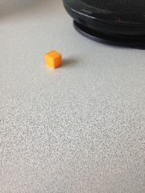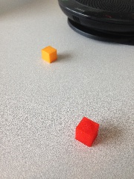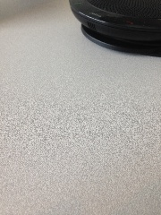

Set of background segmented images using default parameters:

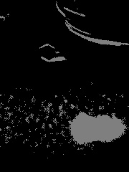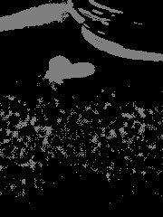

In the above processed images we see that:

* Foreground image 1: Since it is the first fed image, the background model is blank, hence it has detected the whole image as foreground. Grey scale determines any new pixel introduced.
* Foreground image 2: Now we have a background model formed with first image. Hence it detects a new object, here the yellow cube as foreground.
* Foreground image 3: Now the background model is updated with yellow object in background. Hence detects new foreground, here the red cube.

After completing Background Segmentation, what remains of our image is a black and white version of it, black meaning static background and white denoting the moving objects. In order to achieve our final main goal, we need to detect the contours of the moving objects.

Another approach to create a binary version of the image is to compute the difference between the current frame and the initial frame. This operation can be done using the cv2.absdiff function provided by the OpenCV library. This function performs the absolute difference between two input strings or between an array and a scalar.

Once we have an image defining the difference between the two frames, we can actually get to the step of binarisation. This is done using the thresh function provided by OpenCV. This function’s working principle is simple: if a pixel color value is below a specified threshold value, that pixel will be colored in black, otherwise it will be colored white.

To find the outlines of the moving objects in the image that has the mask applied to it, we are going to use OpenCV’s findContours function. Then, we are going to approximate the contours we find using rectangles and drawing them on our initial unmasked image. To do this, we will use the OpenCV rectangle funciton.

In the end, to obtain the practical application of this project, certain sections of the image are going to be marked (representing the museum areas that visitors are prohibited to enter). The bounding boxes the application creates for each moving object (the people visiting the museum) are going to be permanently checked for their position. If they intersect a prohibited area, a signal will be sent to the security systems to inform that a person is located too close to an exhibit. The intersection between the two rectangles is computed by the basic algorithm of finding the maximum value between the top left corner points of the rectangles and the minimum value between the bottom right corner points of both rectangles. Since the actual coordinates of the resulting points do not matter for our application, we only save the width and height information of the intersection rectangle.

Having completed all the above specified steps, we can compute the area of the intersection rectangle between the bounding boxes of the moving objects and the prohibited area rectangles and decide if we have an intersection or not. In case of intersection, the area of the intersection rectangle is going to have a value smaller than zero.

1. **Implementation**
   1. **Structure**

The application development starts by importing the cv2 module, which makes available all the functionality needed to capture video from camera, subtract the background, transform the initial image into a black and white version of it, perform Gaussian blur, find the contours for the moving objects, create bounding boxes, display the image and more functions which are going to be helpful for achieving the final result. Another significant library that needs to be imported is NumPy, the fundamental package for scientific computing with Python, which is going to be used to create powerful N-dimensional array objects.

* + 1. **Getting video input from the WEB camera**

To obtain video from the WEB camera, we need to create an object of class VideoCapture. As input, the constructor of this class receives the index of the device we want to use. In my case, having a single camera connected to the computer, the argument that is going to be passed in this application is the value 0.

*cap = cv2.VideoCapture(0)*

After this, we can start reading the video from the camera frame by frame. To do this, we call the read() method on the VideoCapture object. This method takes no arguments and returns a tuple. The first value returned by this method is a Boolean value that indicates if the frame was read correctly. This value can be used to check for errors if it is needed to confirm that no problem occurred while reading the frame. The second returned value is a numpy ndarray object representing the captured frame.

*ret, frame = cap.read()*

Finally, to display the captured frame, the function that needs to be called is imshow(), which also belongs to the cv2 module. The two inputs that need to be provided for the imshow() function are: first, a string representing the name of the window; second: the image to display. This function is responsible for opening a window in which it displays the frame. In order to be able to constantly check on the evolution of the system and to better understand the way it behaves, we are going to display three windows:

1. The original image on top of which we will add the bounding boxes resulted from computations;

*cv2.imshow(‘Security Feed’, frame)*

1. The original image with a black and white mask applied to it, as well as some blur to reduce the noise;

*cv2.imshow(‘Thresh’, thresh)*

1. The image with the background subtractor applied to it, together with some morphological operations which will be described later;

*cv2.imshow(‘Frame Delta, frameDelta)*

Since our application has to continuously read and display the frames from the camera, we need to perform these operations in an infinite loop. Calling the imshow function multiple times for the same window will override the previous image with the new one.

To be able to end the loop, we will use a waitKey function from the cv2 module to check if a given key was pressed. This function receives as input parameters a delay to wait until the key is pressed, expressed in milliseconds. It returns the pressed key as a number. We are going to use the escape key to exit the program.

*if cv2.waitKey(1) == 27:*

*break*

Finally, the cv2 function destroyAllWindows() is called to destroy all the windows created to show the frames of the camera.

*cv2.destroyAllWindows()*

* + 1. **Subtracting the background**

The background subtractor algorithm initially chosen is called Mixture Of Gaussians (MOG2). First, we need to create an object of class BackgroundSubtractorMOG2. When instantiating, this class uses as constructor input variables the parameters *history*, *varThreshold* and *detectShadows*.

The *history* parameter tells the algorithm how many frames it should take into account when performing the subtraction between images. The value that was chosen for this particular implementation is 100, since the default was 500 and such a value was not allowing the algorithm to detect very quick changes.

The *varThreshold* parameter determines how well a pixel is described by its background model. The value we provide for this attribute is 50, as the default of 16 was allowing the creation of too much background noise which interfered negatively with the final detection of the moving objects.

The third parameter that we provide is *detectShadows*, which determines whether shadows are given importance in the scene and signals the algorithm to detect them. The default is True, but for our application this is going to be set to False, to reduce the complexity of the contours we need to find.

*fgbg = cv2.createBackgroundSubtractorMOG2(history=100, varThreshold=20,  detectShadows=False)*

All the values chosen for these parameters have been selected using a heuristic approach and the tests performed in order to reach optimum values will be described in a later section.

After creating our backgroundSubtractorMOG2 object, we read the images and apply our instance of background subtractor to the frame. This operation segments the background in the image based on the background model so far. Then, it updates the background model to have an even stronger model on which to determine which pixels belong to the background. These updates are performed in the loop created at the previous section that concerned the capture of the input image. It is done so in order to provide permanent and accurate new information for the model. The line responsible for applying the algorithm to our frame is:

*fgmask = fgbg.apply(frame)*

However, a more efficient approach for our particular problem would be to save the first frame from the video input and constantly compare the current frame to the first frame in order to see the differences that occured.

The first frame is defined as following:

*frame = frame if args.get("video", None) is None else frame[1]*

This means that we either save the first frame from the webcam image if there is no video file argument parsed to the program, or we save the first frame from the video input file.

Another functionality of the application is the possibility to refresh the first frame to which the application compares the current frame. This is possible by pressing the keyboard key R.

The function used to perform the frame differences is cv2.absdiff, whose structure is defined below:

*cv2.absdiff(src1, src2 [, dst])*

This function calculates the pre-element absolute difference between two arrays or between an array and a scalar.

After performing this difference between the images, we convert the resulted image to a binary image composed of only black and white pixel colors.

Afterwards, this binary image is dilated to fill in the holes in order to provide a noiseless image for the contour finding part of the application.

* + 1. **Applying the bounding boxes**

In order to apply bounding boxes, one must first have the knowledge necessary about the objects they should cover. To acquire such knowledge, we need to apply a contour detection algorithm. Contour detection can be implemented by the function *findContours()* from the openCV library. Its input parameters are *image*, representing the image on which we apply the algorithm, *mode* – the way of finding contours, and *method* – the approximation method for the detection. The last two parameters, *mode* and *method* are crucial for an accurate detection of contours of the objects that interest us.

The *mode* chosen here is *cv2.RETR_EXTERNAL*. This mode indicates that the algorithm should only retrieve the extreme outer contours. The *method* used is *cv2.CHAIN_APPROX_SIMPLE*, which makes the function return only the endpoints that are nexessary for drawing the contour line. The output of this function is the image, the detected contours and their hierarchy. The returned contour is a list of points consisting of the contour lines.

To draw the outer lines of the moving objects, we will sort them by contour area and will approximate their shape to a rectangle. The goal of the sort is to only take into account a *MAX_NUMBER_BOXES* number of contours, as to reduce the false signals given by possible remaining noise. The value chosen for our experiment is 5.

The contours are stored in the variable *cnts* like this:

*cnts = cv2.findContours(fgmask.copy(), cv2.RETR_EXTERNAL, cv2.CHAIN_APPROX_SIMPLE)*

Next, since there may be library version conflicts and the *findContours()* function from the openCV module might not come from the version we expect when deploying the application on another computer and simply to increase security, we are going to use the convenience function *grab_contours()* from the *imutils* library. This function checks the dimensions of the contours given by the *findContours()* algorithm. The basis of its logic is that if the contours have a dimension of 2, then the openCV library version that was used is either OpenCV v2.4, v4-beta, or v4-official. In this case, the actual contour coordinates can be found in *cnts[0]*. Otherwise, if the contours’ dimension is 3, we are using either OpenCV v3, v4-pre or v4-alpha. In this situation, we need to extract *cnts[1]*.

So, the line responsible for this operation is the following:

*cnts = imutils.grab_contours(cnts)*

To sort and extract the n largest contours, we use the *heapq* library function *nlargest()*. Its inputs are *n* – the number of largest items we need to extract, the *iterable* is the set of elements which we wish to sort and it may also accept an optional parameter *key* that, if provided, specifies a function of one argument that is used to extract a comparison key from each element in the iterable. This function returns a list with the *n* largest elements from the dataset defined by *iterable*.

In our case, the function parameters are given like this:

*maxc = heapq.nlargest(MAX_NUMBER_BOXES, cnts, key = cv2.contourArea)*

Finally, to find the approximation of our shape into a rectangle, the OpenCV function *boundingRect()* is used. This function calculates the minimal up-right bounding rectangle of the specified point set. In Python, the only input parameter it requires is the set of points to approximate.

To actually draw these rectangles on our image, we use the OpenCV *rectangle()* function. Its parameters are *image* – the image on which the rectangle is to be drawn, *start_point* – the starting coordinates of the rectangle, *end_point* – the ending coordinates of the rectangle, *color* – the color of the border line of the rectangle to be drawn, *thickness* – the thickness of the rectangle border in pixels. The coordinates are represented as ruples of two values. The return value of the function is an image.

Since we wish to perform these operations on all the identified sets of contous, we apply rectangles in a for loop, as follows:

*for c in maxc:*

*rect = cv2.boundingRect(c)*

*x,y,w,h = rect*

*cv2.rectangle(original,(x,y),(x+w,y+h),(255,155,0),2)*

* + 1. **Reducing the noise**

Since noise is a significant problem when trying to only observe the moving ojects, several tuning methods need to be applied to our images.

First of all, the initial image should have its color-space changed from BGR to Gray. For color conversion, we use the function *cvtColor()* provided by OpenCV. This function takes as input parameters the *input_image* and *flag*, which determines the type of conversion. For conversion from BGR to Gray, we are going to use the *cv2.COLOR_BGR2GRAY* flag.

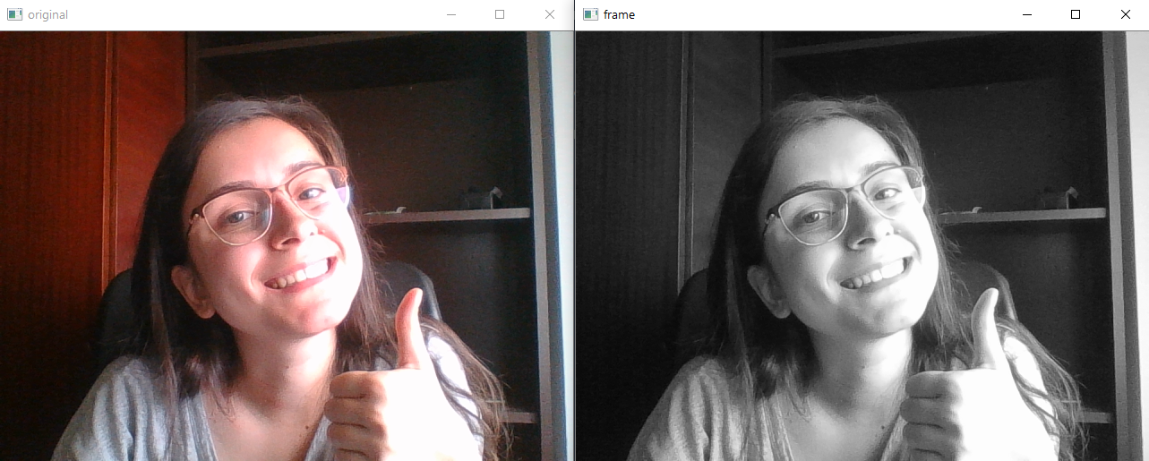

Now, the noise given by change in color is significantly reduced, but we still have variations in light intensity that need to be taken care of. For solving the problem of small pixels that cause noise, we will apply Gaussian Filtering on the Gray image. For this approach, we will use a Gaussian kernel. This is done with the function *GaussianBlur()* provided by the OpenCV module. For the kernel, we need to specify the width and height, which should be positive and odd.

*kernel = np.ones((5,5), np.uint8)*

The parameter *np.uint8* represents an unsigned integer value that is between 0 and 255.

Gaussian filtering is highly effective in removing Gaussian noise from the image.

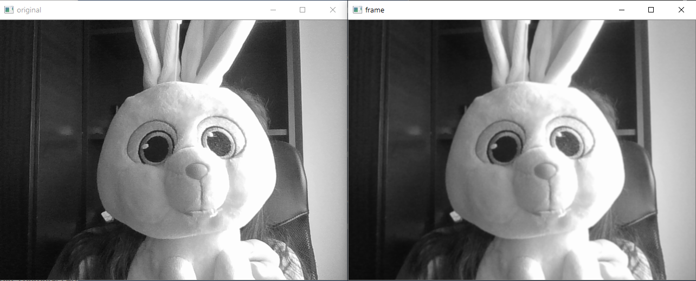

Now that the image is all grey, smooth and with significantly less noise than initially, it is ready to go into the process of becoming a binary image, performed by the Background Subtractor.

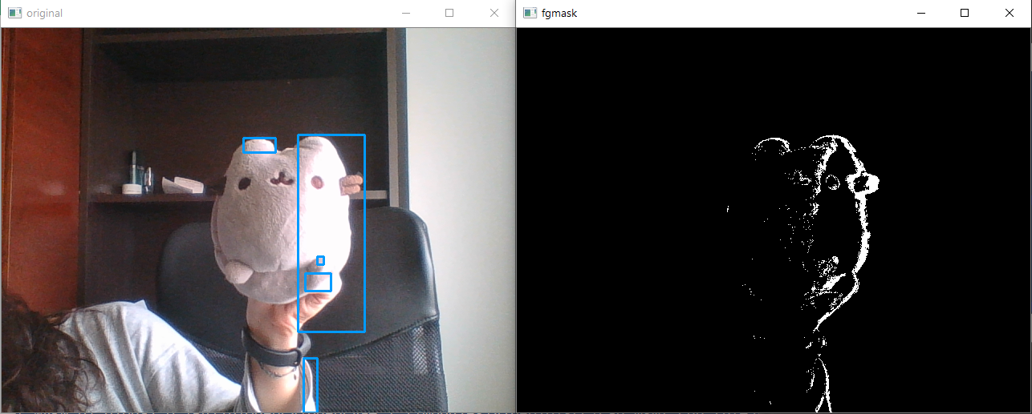

Now, the problem is that our very denoisified image finds more contours in a single object. The solution to this issue is Morphological Operations. These operations are a set of functions that process images based on shapes. They apply a structuring element on an input image and generate an output image. The most basic morphological operations that are also going to be used in this application are Erosion and Dilation.

The basic principle of Erosion is that it erodes away the boundaries of the foreground object and diminishes the feature of an image. It is useful for removing small white noises and detaching two connected objects.

*fgmask = cv2.erode(fgmask, kernel, iterations=1)*

On the other hand, Dilation increases the object area and is used to accentuate features by increasing the white region in the image or the size of the foreground in the image. In our case, Dilation needs to follow Erosion. The reason for that is the fact that Erosion performs white noise removal, but it also shrinks the object. So we dilate it. Since Erosion took take of the noise, it won’t be an issue that it might come back, but the area of the object we are actually interested in increases. Dilation is also useful for joining broken parts of an object.

*fgmask = cv2.dilate(fgmask, kernel, iterations=1)*

* + 1. **Finding intersections**

In order to compute the intersections between the bounding boxes and the forbidden areas in a reduced amount of steps, I have defined a function that takes as input parameters the coordinates of the bounding box and the parameters of the forbidden areas, defined as top left corner coordinates and bottom right corner coordinates.

The algorithm for computing the intersection between two rectangles is presented in the following image:

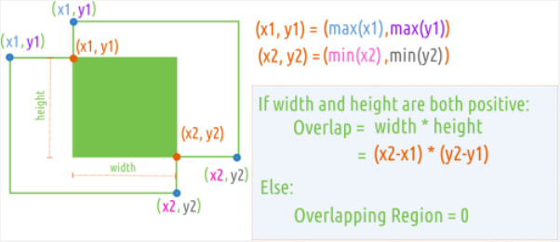

We are ultimately interested in the area of the intersection rectangle, so there is no actual need to store the coordinates of it, but rather the width and height resulted from the intersection, which will be used to compute the area of the intersection rectangle. Therefore, the final information that needs to be checked is the area of the resulted rectangle, computed by the formula:

*Area_Rectangle = Width * Height*

Having this information, an area greater than zero denotes the fact that we indeed have an intersection between the bounding box and the forbidden area rectangle.

* + 1. **Defining forbidden areas**

The definition of the forbidden areas on the camera is done by manually coding a set of rectangles, each of them being defined by two points that follow the rule that we first define the top left corner of the rectangle and then the bottom right corner.

For simplicity of testing, this application has three such areas defined:

*r1p1 = (50,60)*

*r1p2 = (100, 95)*

*r2p1 = (250,260)*

*r2p2 = (300, 295)*

*r3p1 = (50, 200)*

*r3p2 = (100, 230)*

The naming convention used for these points is of the form *ripj,* *ri* representing the ith rectangle and *pj* representing the jth point of the rectangle.

The rectangles have been drawn on the image using the OpenCV library function cv2.rectangle():

*cv2.rectangle(frame, r1p1, r1p2, red, -1)*

*cv2.rectangle(frame, r2p1, r2p2, red, -1)*

*cv2.rectangle(frame, r3p1, r3p2, red, -1)*

Using this function we can observe why it is important to define the rectangles in terms of opposite points, since that is the way the cv2.rectangle function requires rectangles to be passed.

* 1. **Finding the right parameters**

To find parameters as adequate as possible for our problem of background subtraction, an heuristic approach was used. The process went as following:

1. Implementation using only the MOG2 function with default parameters

This approach was susceptible to a lot of noise which, on a more complicated image will cause a mistaken observation of more objects than there are actually moving in the image. You can see the noise created by this approach in the right hand side image. Even though this approach was acceptable for this case, it is obvious that it will not perform as well on a greater, more sophisticated image.

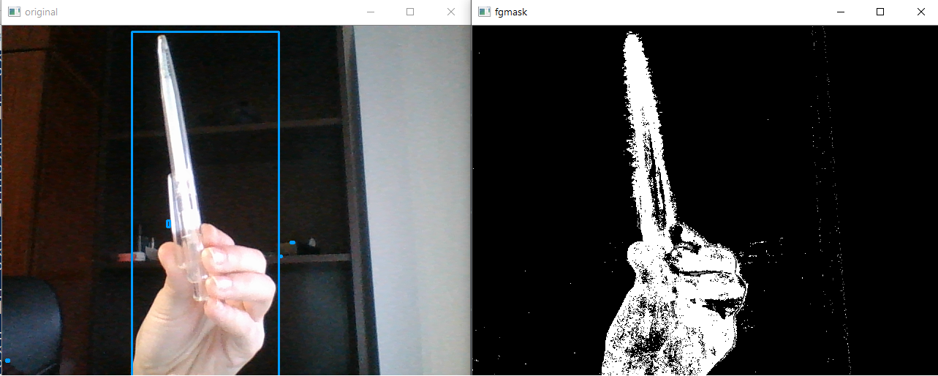

1. Implementation using MOG2 with better parameters

In this case, you can see that the background noise has been significantly reduced. However, it is still present and will negatively influence the outcome of our application. Moreover, now it detects multiple boundaries within the same object.

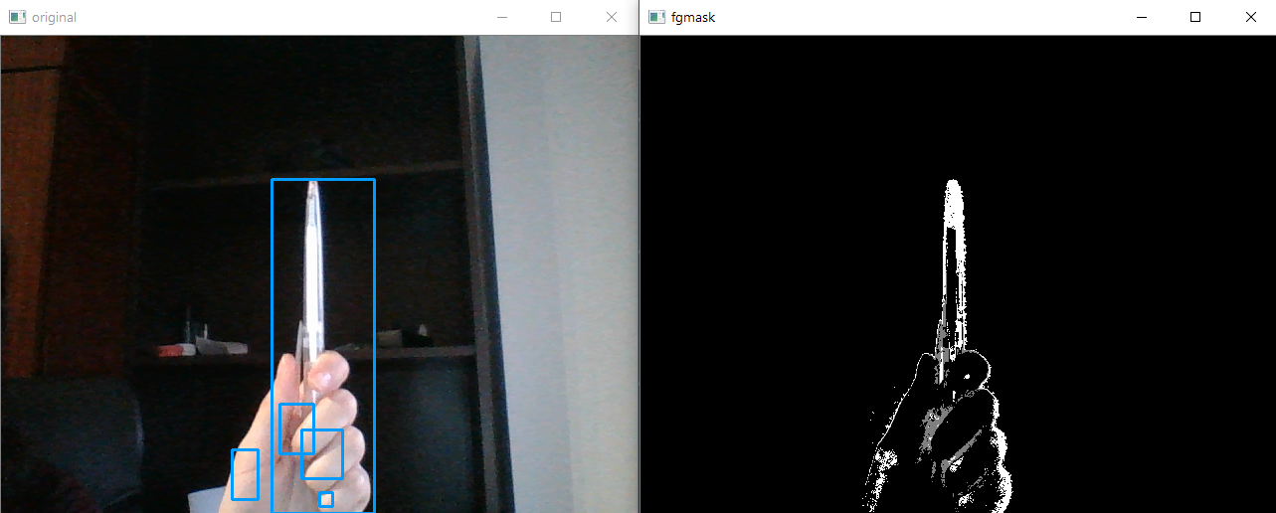

1. Implementation using MOG2 with better parameters than the default ones and the initial image’s color space has been changed to Gray and blurred

It can be noticed that noise is almost completely gone and out object is properly detected. However, this is far from perfect, as there are still more contours found within a single object.

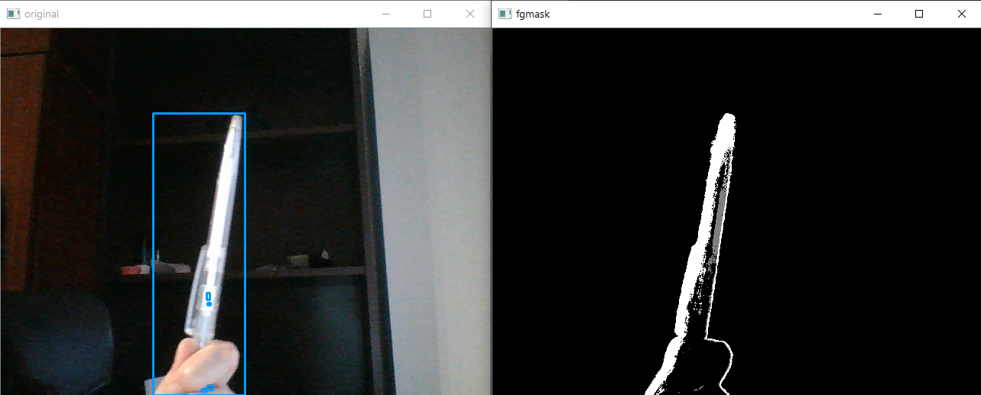

1. Everything above plus Erosion and Dilation

As it can be seen in the below pictures, the application does a much better job in extracting boundaries of the moving objects.

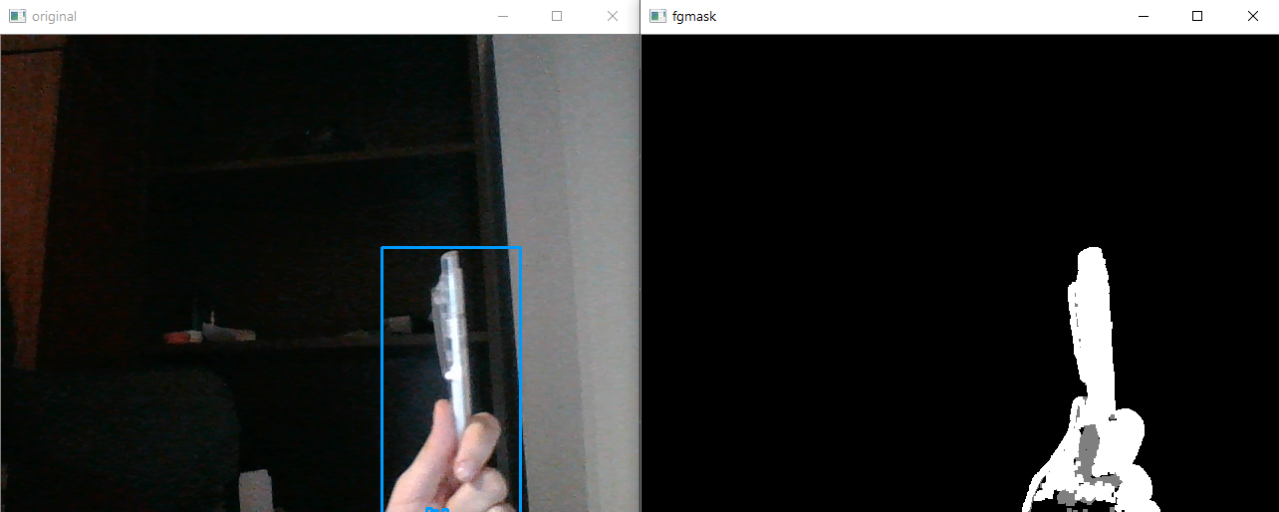

The above observations regarding the tuning of the parameters used for the MOG2 function can be described in a table as following:

|  |  |
| --- | --- |
| **Values** | **Observations** |
| **Default values**  History = 10  Threshold = 50 | Lots of flickering in the image  Not much noise |
| History = 10  Threshold = 10 | Lots of flickering  Lots of noise |
| History > 100 | Background improperly subtracted – subtracts too much from the large objects as it considers the center of them to be part of the static background if they have a solid color |
| Threshold > 50 | Does not detect small movement as it identifies the moving object with the background |
| History = 100  Threshold = 20 | Optimum values for our problem |

These values have been tested with the detection of shadows turned off, since in our particular case they should not influence the outcome of the application too much.

The final testing was done using another approach to the detection of the moving objects. This approach required that we save the first frame of the video input for reference, and then we keep performing the subtraction between the current frame and the first frame in order to find what has changed between the two frames. This approach is very dependent on the fact that the camera needs to be static, but it has no issue for the particular problem this application tries to solve.

Having this as the initial frame:

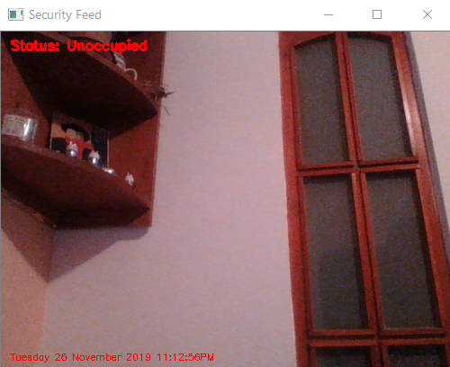

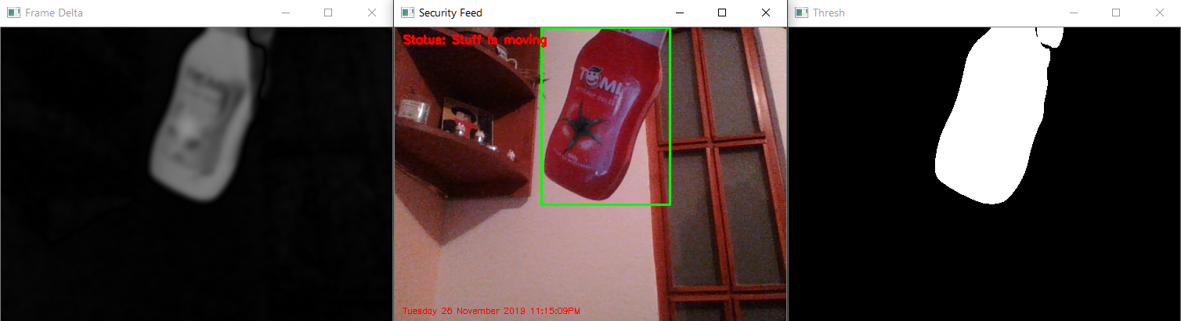We can see in the top left corner of the frame the status of the room. The moment a foreign object enters the frame, the application detects it and applies a bounding box around it and changes the status of the room:

Adding the forbidden areas as red rectangles, we can now inform the application user if a moving object intersects one of the forbidden areas:

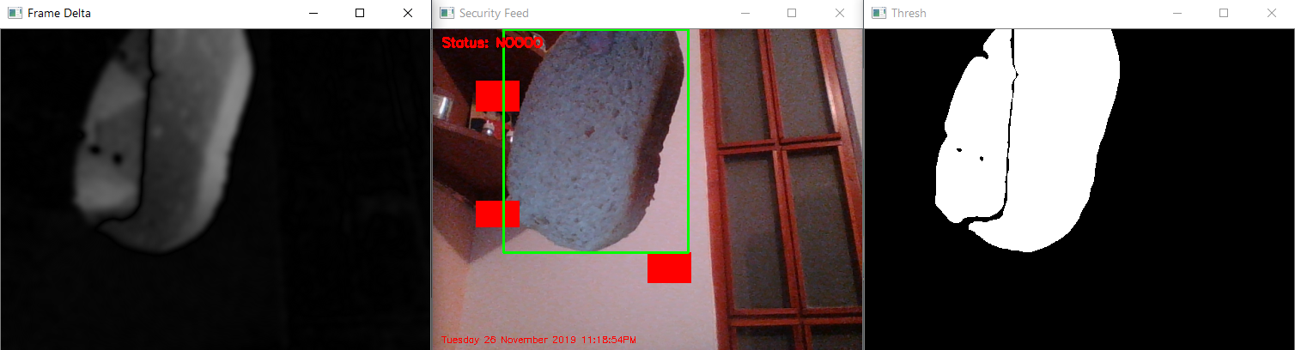

* 1. **Application arguments**

It is possible, if required, to apply this functionality on a recorded video file by passing the video file path as argument to the application when calling it.

*ap = argparse.ArgumentParser()*

*ap.add_argument("-v", "--video", help="path to the video file")*

*args = vars(ap.parse_args())*

Therefore, the application can be started through the terminal by using this command:

*python project.py –v ./videos/video_example.mp4*

* 1. **Application flow**

A happy flow of the diagram occurs as following:

Get video input

Denoisify

Apply Background Subtraction

Find contours

Apply rectangular bounding boxes

Show image

End of program

Check bounding boxes

Intersect prohibited area

yes

no

no

yes

1. **Testing**

The testing of the application was done continuously from the beginning of its development. It has been tested after each functionality described above was introduced in order to discover possible problems early and perform the required modifications in the early stages. This approach resulted in a significantly reduced time spent for solving bugs after completing the application. The testing method that was employed is Manual Testing, which consisted in standing in front of the WEB Camera and checking if motion was detected correctly, if bonding boxes were applied properly and if movement in the forbidden areas was identified and the system warned about it.

Testing was performed using the two scenarios available to this application: using the WEB camera and using an already recorded video footage.

As long as the camera position is still, the application correctly identifies most of the movement as long as it complies with the system hyperparameters. The only issue met with this functionality is that the system sometimes breaks one moving object or person into several smaller objects. However, this issue does not interfere with the detection of objects in the forbidden areas.

As for the actual detection if bounding boxes intersect with the forbidden areas, the system correctly identifies most of the cases, but it sometimes fails to do so on some particular cases of intersection.

* 1. **Testing with the WEB camera**

The image presented below is the initial frame captured by the WEB camera. As this is the first frame and nothing is moving, its status is UNOCCUPIED, as it can be seen in the top left corner of the window.

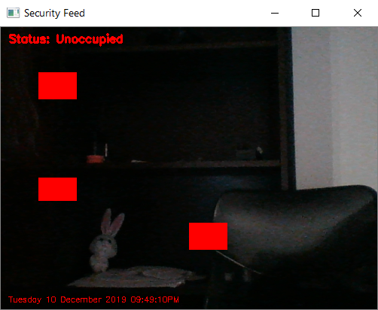

Following, our assistant, Tibbers, enters the camera and the system identifies that there is movement happening, so it informs us by setting the status to Stuff is moving.

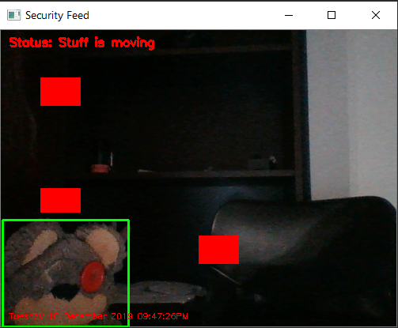

In the next image, Tibbers has entered a forbidden area and the system is signaling this incident by setting the status to WARNING.

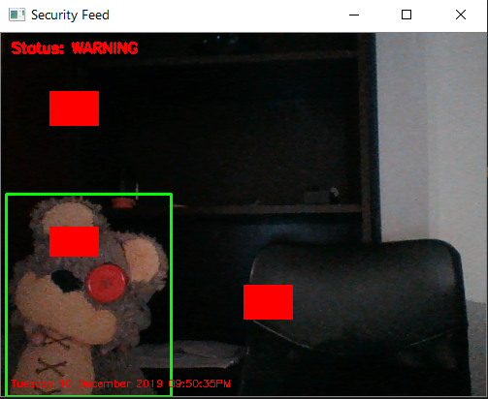

As Tibbers moves to the right, he enters another forbidden area and it is also signaled by the system using the same warning status.

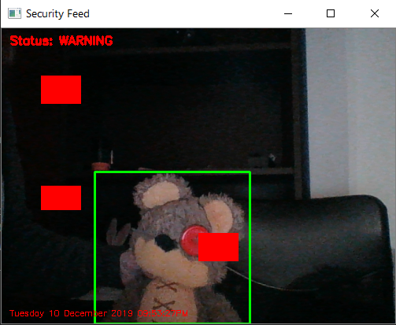

As a final attempt, Tibbers tries to be sneaky and enter the forbidden area upside down. The system is agnostic to the actual body position of the stuff entering the camera, since it only detects the movement that is happening. Therefore, the system warns us again that somebody has entered a forbidden area.

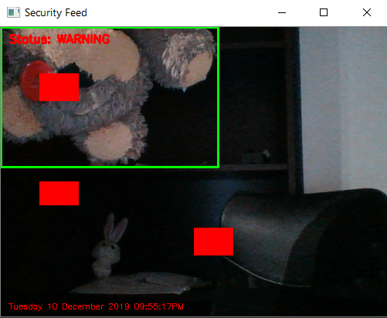

* 1. **Testing with a recorded video footage**

This is a footage of a pigeon relaxing on a sidewalk. The following image represents the initial frame:

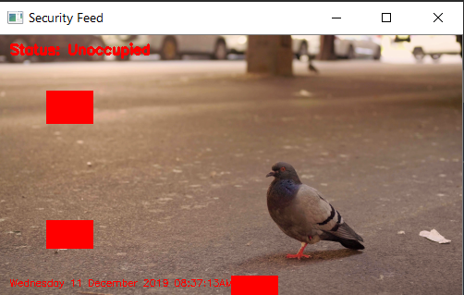

The camera is not perfectly still, so we can detect some movement in spots where nothing happened. However, we capture the movement of the other bird moving in the top right corner of the window. The main pigeon has also moved a little bit, so it is now placed in a bounding box. The status of the camera is now signaling Stuff is moving. This image also captures the cases in which the application has problems identifying intersection between the bounding boxes and the forbidden areas. In the top left side of the frame there are two bounding boxes which intersect the forbidden area but the system fails to detect that.

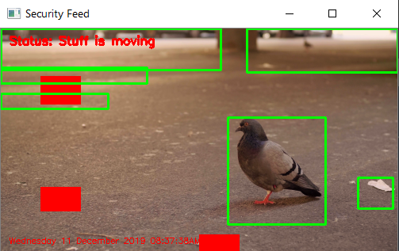

In the following frame, a person is walking by the pigeon. This image shows how the system sometimes breaks one moving object into several smaller objects if the movement is not uniform across the entire object (for example a leg and a foot have distinct movement patterns and the application separates them into two different objects, even though they belong to the same leg). Besides that, the moving person enters a forbidden area and this is properly signaled by the system by setting the status to WARNING.

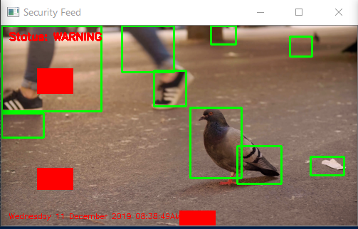

1. **Conclusions**

Since this topic was not taught in University, I had to conduct a lot of research on the subject of Computer Vision. After documenting about OpenCV and its functionality, I tried to develop an efficient application that is capable of detecting the position of objects that are moving using a WEB Camera. The final result is an easy to use application that identifies these positions correctly most of the time.

The main tasks of the project were getting information about the objects that are moving and applying rectangular bounding boxes around these objects in order to prove the position identification capability of the system. Differentiating the moving objects from the static background was done using a method called *Frame Subtraction*. This was possible by saving an instance of the initial frame and calling *cv2.absdiff* between it and the current frame in order to detect changes that occured.

The other major task was applying bounding boxes and computing the intersection between them and specific areas in the frame. After binarising the input frames, we can easily apply *cnts = cv2.findContours* on each frame and this function will identify contours of a color that we provide; in our case, this is looking for white areas in the image. The intersection was computed using a basic algorithm written by me.

This application could be improved by implementing a better algorithm for the intersection computation problem, since this is where the system sometimes fails to provide a correct answer. Another aspect that could be improved is making the application work on a camera that is not static.

1. **Bibliography**
2. <https://docs.opencv.org/3.4/d5/d69/tutorial_py_non_local_means.html>
3. <https://www.geeksforgeeks.org/erosion-dilation-images-using-opencv-python/>
4. <https://docs.opencv.org/3.4/d7/d7b/classcv_1_1BackgroundSubtractorMOG2.html>
5. <https://en.wikipedia.org/wiki/Foreground_detection>
6. <https://techtutorialsx.com/2019/04/13/python-opencv-getting-video-from-camera/>
7. <https://numpy.org/>
8. <https://github.com/jrosebr1/imutils>
9. <https://docs.opencv.org/3.1.0/dd/d49/tutorial_py_contour_features.html>
10. <https://www.youtube.com/watch?v=V9Hup-wImfA&feature=youtu.be&fbclid=IwAR31kZA9wq4GPtcXOvzdyuJ5ZjwUx4VKp9VeCLwA5i-W0rcefaBBjSWR82s>
11. <https://www.youtube.com/watch?v=8-3vl71TjDs&feature=youtu.be&fbclid=IwAR2KnW-9eQzwQHaoWWdhjY32edAV8Cai5QpScHAnSd4I6bA5i1k-R2WI7KM>
12. <https://gamedev.stackexchange.com/questions/586/what-is-the-fastest-way-to-work-out-2d-bounding-box-intersection>